raindrops instructions

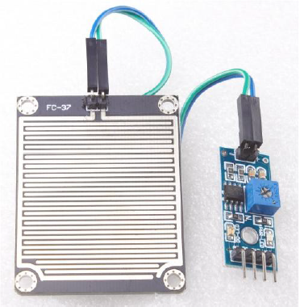

Product use:

Arduino robot kit, rain, rain sensor, can be used to monitor a variety of weather conditions, and turned into a number of fixed signal and AO output.

Product introduction:
1, the sensor uses a high quality FR-04 double-sided materials, large area 5.0*4.0CM, and with nickel plated surface, with a more superior performance against oxidation, electrical conductivity, and life expectancy;

2, the comparator output, the signal is clean, the waveform is good, the driving ability is strong, more than 15mA;

3, with potentiometer adjustment sensitivity;

4, working voltage 3.3V-5V

5, output mode: digital switching output (0 and 1) and analog AO voltage output;

6, a fixed bolt hole, easy to install

7, small size: 3.2cm x 1.4cm PCB

8, using a wide voltage LM393 comparator
Function introduction:

Connected to the 5V power supply, the power indicator light, no water droplets on the sensor board, the DO output is high, the switch lights off, a drop of water, DO output is low, the switch indicator light,

Brush off the water droplets above, and restored to the output high level state.

AO analog output, can be connected to the AD port of the microcontroller to detect the drop in the above amount of rainfall.

TTL DO digital output can also be connected to the microcontroller to detect whether there is rain.
Connection mode:

1, VCC: connected to the power supply cathode (3-5V)

2, GND: connected to the negative electrode

3, DO:TTL switch signal output

4, AO: analog signal output
\

